Three Writing Samples By Christine D. Allen
The Perils of Hyperreaction & Overcorrection  Last year, white-knuckle weaving through night traffic in Izmir, Turkey, I answered a call from the U.S. “You have two minutes to say good-bye to Dad,” my sister said. Doctors were to put him on a ventilator, and he wasn’t expected to live through the next night. “No! I have something for him. Tell him he has to wait!” Neither my demand nor my little gift, which I’ll describe momentarily, determined his fate. What kept him alive, more likely, was that the hospital had run out of ventilators.  In the early stages of the COVID-19 pandemic, people dying on ventilators seemed a matter of course, with parallel causal trajectories: Patients needed ventilators because they were very sick; patients died because they were very sick. Over time, research questions became more nuanced—were people dying on ventilators more frequently because of their degree of sickness or because the invasive ventilators introduced additional risks? Answers are less than definitive, but study results certainly suggest that jumping the gun on ventilators can be deadly.  This spring I watched my 85-year-old dad scale a slab of redrock, thinking about the hazards of overcorrection—in traffic, in domestic strife, in sociopolitical crises, and so on. As the U.S. deals with inflation, slowed growth, stressed supply chains, rising costs of housing and transportation, and a need for labor reform during election midterms, one wonders how Janet Yellen will keep her cool through fall, if any more unforeseen circumstances arise. Ms. Yellen will do what Ms. Yellen will do. But how can the rest of us keep our cool—and our capital—as we watch international and domestic conflicts unfold, ice caps melting, and a march toward famine? Sometimes a little tried-and-true is what gets us through the ever-changing.  Be Aware of Cognitive Biases behind Overreactions  Reacting to extreme optimism or pessimism emerging from market chatter can lead to unnecessary losses or inhibited gains. Eventually reversion brings markets to long-term valuation levels, so devising a sensible long-term plan and sticking to it, despite all the chatter, can prevent investors from kneejerk selling during downturns, which locks in losses.  Let’s take a look at a few other biases behind hyperreactive overcorrections—including optimism, overconfidence, risk-aversion biases, as well as a subset of the latter, the loss-aversion bias. | [Callout 1] What Is a Market Correction?  A correction is often understood as 10% to 20% decline from a security’s peak price. Corrections to individual assets or to an index measuring a group of assets can occur over days, weeks, or a few months. Overcorrections exceed a 20% decline.  [Callout 2] Who Tracks Corrections and How Reliable Are They?  Investors, traders, and analysts generate market chatter and charting strategies to identify factors in market corrections, their causes, and their likely outcomes. Expertise matters, but no single advisor can predict the unpredictable.  [Callout 3] Are Corrections More Painful or Positive?  Corrections in the short-term can be crushing for those easily swayed by herd mentality, panic, and daily chatter. Read on for tips on enduring corrections with potentially steady gains and new buying opportunities in the long run. You might want to take advantage of buying high-value assets at discounted prices, or you might mitigate declining equity prices with stop-loss and stop-limit orders.

The Optimism Bias  Optimism biases and overconfidence biases are related, but they stem from different core beliefs. Enthusiasm in one’s career allows us to persevere, even when our personal, professional, and macroeconomic situations get tough, yet it’s important to understand the limits of optimism. When a sense of good luck and well-being seem mandatory in our workplaces and even our self-concept, we might have “intuitive”—and erroneous—feelings about inevitably positive market returns. Be cautious.  TIP: Don’t make forecasts based on internal “gut feelings” alone—look externally at a rough distribution of outcomes among a class of similar assets within a given timeframe. How has your gut feeling measured against external, multiplicitous analyses? It’s worth charting, but it’s a step in your decision-making process you should never skip, because no investment is free of risk. Factors outside of your control, beyond your advisor’s control, and even outside of any country’s leader’s reach, can easily usurp your feelings. Read more here [internal link 1 (IL1)].  The Overconfidence Bias  The overconfidence bias is at work when we overestimate our skills, capacities, and performance, and it’s rooted mostly in a desire for more control than one actually has. In some it takes shape in less perceived responsibility and guilt for irrational or unfair practices. You’ll see overconfidence bias in investors who believe they have unique above-average insight that will lead them to inevitable success as compared to other investors. People with overconfidence bias often take on too much risk and underestimate how long it might take for an investment to pay off (known as planning fallacy).  Disparities between an investor’s self-assessments and the performance of their investments might be clear to everyone around an individual, but the bias often leads one to fabricate explanations for this or that “real cause” of the problem—which, the investor would say with confidence, has little or nothing to do with his or her own overconfidence. To some extent, the individual might be right—tightening supply chains, increasing costs of oil, climate change, and so on might very well contribute to poor performance. But understanding one’s own limitations could very well balance the effects of market turmoil.  TIPS: Check yourself for the desirability effect when you notice your predictions don’t always seem reflected in gains. That is, weigh your desire for a given outcome regarding an investment and your self-concept against aggregate results from multiple exchanges. From where does your confidence derive—from your education, your institutional affiliation, your heritage? Expertise, connections, and exhaustive research count; but they can’t account for factors beyond your control. Take inventory of factors outside of your control that might influence the performance of your investments. Read more here [IL2].  The Risk-Aversion and Loss-Aversion Biases  Investors with RISK-AVERSION BIAS sometimes prefer low-interest investments like U.S. Treasury bonds, certificates of deposit, conservation allocation funds, and high-credit-quality municipal bonds. They are highly sensitive to making decisions with uncertain consequences. They sometimes insist on compensation for risk through a risk premium. Generally, more wealthy individuals, especially those who’ve inherited wealth, tend to be risk adverse. They’d prefer protecting their principal over growth because, as they say in behavioral economics, “losses loom larger than gains.”  Those with LOSS-AVERSION BIAS demonstrate both risk-averse and risk-seeking behaviors. They fluctuate easily and quickly from pride to fear, so they particularly need reasonable risk parameters to avoid emotionally driven investment decisions.  TIPS: Consider a broader perspective, looking at tax benefits, opportunities for other investments, and so on to reframe your perception of risk if you’ve found risk aversion has cost you too much. Remember that sparing yourself from any degree of uncertainty can mean passing up other potentially long-term, sound investment opportunities. People nearing retirement might consider target date funds—a mix of stocks and bonds that present potential growth early on and become less risky over time. If you have loss-aversion bias, avoid impulsive herd-instinct behaviors such as IPO first-day flipping or prematurely moving funds to low-risk interest-rate securities. Read more about coping with the uncertainty inherent in investment here [IL3].  Neither Economies Nor Portfolios Need Ventilators  During the pandemic, hyperbolic metaphors consumed the media, and the media often consumed our best efforts to manage our pervasive sense of uncertainty. Putting the economy on a ventilator was a favorite: ventilators took the forms of lockdowns, insurance expansions, conditional cash transfers, and other stimulus programs. But in fact economies don’t require ventilators; they require the instruments of analysis over time, and unlike the ventilator my father didn’t receive, these instruments don’t introduce additional risk but counter triggers for emotional trading, including hyperbolic language and panic-ridden, overreactive market chatter.  The gift I brought my father meant something to him—and to me. It’s an adult figure holding a baby across the chest—an amulet from the vicinity of the Asklepion in Pergamon (now Bergama, Turkey). I was born with hyaline membrane disease and wasn’t expected to live, so I slept on his chest every night for my first few months. It was then, he said, that he first felt like a father, despite that I was his fifth baby. My dad, a lifelong atheist, survived long enough that I could bring the amulet, and once he had it in his hand, he held onto it like his life depended on it. It still sits on his nightstand. The tool, after all, wasn’t meant to cure him but to distract him from the overwhelming stress of a close encounter with death.  I’m not suggesting investors find themselves an amulet; I’m suggesting that you can use any tool you want if it’ll help you stay calm enough to avoid overreacting during market corrections. Investment performance isn’t about a fleeting sense of flow or intuition; it’s not about any one person’s incomprehensible acumen; and it’s not about playing it safely into stagnation. It can be about hiring trusted advisors and about dragging your decision-making self out of the amygdala (the emotional structure of the brain) and into the logical, emotion-regulating frontal lobe using analytical tools for investors.  Know your cognitive biases, and keep in mind that disciplined adherence to a few rules of thumb will take you a long way:  - Don’t lose your cool over exuberant buying sprees without technical, quantitative, and qualitative aggregate analyses of performers in a given class of holdings over a particular timeframe.  - Don’t follow a panicked herd in flipping stocks during market corrections, and don’t liquidate all your assets just to hoard cash in your basement (or savings account).  - And look out for red flags—companies with unethical practices, corrupt leadership, hidden balance sheets, and so on—and more than likely, you’ll weather the corrections and end up investing in holding you can believe in—holdings that are neither under- nor overvalued, that are subject to scrutiny, and that have earned a reputation for some degree of stability. | [IL2] A Little Optimism Can’t Hurt, Can It?  Research shows that investors who base decisions on a core belief in their personal good luck and well-being see returns of at least five percentage points less than other investors. Take part in a motivational program—it’ll make you feel good. But mind your inherently human capacity for cognitive error. When it comes to financial investments, rationality must be your friend.  Consider the Dot Com Bubble of 2000. Nasdaq losses were 77% and recovery took 15 years; tech stocks were overvalued, but investors felt so enthusiastic about earnings, they often failed to look at the stability of companies they invested in. Some abandoned investment altogether rather than enduring market correction, and they lost out on a lengthy bull market. J. Paul Getty’s advice might have served them well: “Buy when everyone else is selling, and hold on until everyone else is buying.”  [IL2] Believe in Yourself! But Not Too Much…  Your superior acumen might help you pick the next big stock or predict values such as next year’s GDP. But if you find yourself investing in a lot of penny stocks, trading too often, ignoring negative feedback that’s contrary to your own findings, you might consider the fact that 74% of professional fund managers believe that they, too, have above-average acumen compared to their colleagues (and they can’t all be right).  Reflect on the Subprime Mortgage Crisis of 2008; the S&P 500 losses were 57%, and it took 15 years to recover. Reckless lending practices in housing loans combined with unemployment required huge government bailouts, cash injections into the economy, and slashed interest rates. Yet the overconfident still insist the FTC regulations protecting consumers from unfair and deceptive practices are over-the-top. Why? Because they know better.  [IL3] Weathering Troubling Times  Mathematician John Allen Paulos wrote, “Uncertainty is the only certainty there is; knowing how to live with insecurity is the only security.” As the world faces pandemic, war, and climate change, we must learn to accept, and not resist, a certain degree of uncertainty. Opportunities for recovery and growth will present themselves. Until then, remember that market corrections are normal, frequent, and usually fast.  Your best bet is to stick to a long-term plan, keep an emergency fund, if you can, of a few months’ expenses to assuage nervousness, pay off high-interest debt, and most importantly, diversify your holdings. And remember that overreaction to corrections—like selling stocks and raising cash when currency is down—will only lock in your losses and prevent potential for future growth.  Remember, not everyone lost out during even the Great Depression. Investment in companies that prioritized efficiency or committed to discounted sales paid off for some, while investors like Charles Clinton Spaulding saw growth by investing in life and fire insurance and in banking and mortgages. Howard Hughes invested in a revolutionary technology—aviation—and made a killing. Others survived by unheroic means—insider trading and market manipulation, for example. But today we have the benefit of hindsight: learning about the mistakes of yesterday makes risk-taking today less anxiety-inducing.

Marketing Copy for Sorfeo (Nu Momz/New Moms Brand)
Original Copy | Expanded/Revised Copy
Supporting your motherhood from the beginning. | We’re Here to Support You  New Moms offers support from the beginning of your pregnancy through your postnatal recovery, because we know that an everchanging body calls for more than a doc’s advice and a dozen roses to render the quality of life you well-deserve. It needs tools—tools for everyday therapeutic self-care. And we’ve got a sleek, science-backed tool just for you…
Manage Pain  Our belly band design reduces pressure on your spine while supporting your growing belly for you and your baby. It also helps reduce the pain that comes with edema: a pregnancy condition that causes swelling in the legs, back, hands, and hips.  Stay Comfortable  Feel better and look better with proper pregnancy posture.  Our abdominal binder not only snaps firmly and comfortably around your middle, it does not show unsightly lines underneath your clothing.  Feel better pregnant while you look great pregnant. | TAKE SOME PRESSURE OFF  Take the pressure off your pelvic floor, spinal discs, bladder, and nerves with a strong, breathable compression band.  LOVE YOUR LUMBAR  Feeling the swayback pinch? Your vertebrae are shifting to compensate for a changing center of gravity; return the love—protect them from sharp twists and turns.  PRACTICE SELF-CARE…WITH STYLE  Boost your confidence with the freedom of fashion at home, at work, at school, and in your travels with the targeted comfort and compression of  STAY ACTIVE, STAY EMPOWERED  Your step may feel slippery with softened ligaments, tendons, muscles, and joints, but with our support belt you can still do you—with poise.  WRAP IT UP & FORGET ABOUT IT!  Easy on, easy off—easy wear: 82% of women prefer an elastic, nonrigid belt; they’re comfy and they stay in place, yet offer equal support for posture and pain relief.
Nu Momz has many benefits:  - Reduces back pain  - Reduces round ligament pain  - Reduces SI joint pain  - Reduces pelvic floor pressure  - Aids in post-partum recovery  - Aids in SI joint disfunction recovery  Belly bands help decrease your pain – specifically SI joint and Round ligament pain.  - Provide gentle compression during activities.  - They provide edermal cues for posture. Provide support to enable prenatal exercise.  - They can be worn after pregnancy for support—compensating for decreased core strength which is common in the weeks following birth. | Benefits of the Nu Momz Belly Band  - Plus-size friendly, up to 50” (most are up to 45”).  - Comfortable, soft, breathable, lightweight materials.  - Durable belly bands with reinforced elastic, solid stitching, and Velcro adjustments for custom fit.  - Extra soft and breathable lining next to skin  - Velcro adjustments for custom fit  - We understand you’re looking out for baby, too. The baby’s weight distribution remains secure and intact, preventing unnecessary strain, and lumbopelvic compression reduces risk of falls and other traumatic incidents.  - We see you—your determination, your pain, and your struggle with social, economic, physiological, and internal psychic pressures. We understand that this difficult and wonderous journey is too often dismissed for its commonality, yet the intensity of change, of pain, and of pleasure would be no less powerful if every woman on earth were pregnant at the same time.  - Whether you’re one of the nearly 70% of 21st-century women who work during their pregnancy or invest your time in other pursuits that challenge and add meaning to your life, we want to support you.  - We respect the right to care and comfort for all sizes of women, with a fully adjustable design for petite and plus-size women alike, and we understand that your journey doesn’t end the moment you give birth, contrary to rather popular belief.  - Your body is adapting to hold and deliver your baby. Let us give you one good, empowering tool so you can adapt as comfortably as possible to a world of challenges ahead. Invest in yourself. You’re worth it.
About Us  - Nu Momz is a proud USA-based company. We specialize in the creation and manufacturing of the highest quality maternity belts.  - Our belts provide the berst comfort and support for the demanding bodily changes endured by expecting mothers. | About Us  New Moms is a proud U.S.-based company. We specialize in designing pain-relieving, stabilizing solutions for pregnant women so they can thrive—with as much respect, agency, independence, vitality, and reward as ever!  Our mission is to give you a proven pain-intervention tool that allows you to pursue an active, healthy lifestyle throughout your pregnancy and into postnatal recovery.  We’re committed to listening to your feedback, from the raving review to the note of genuine concern. We carefully consider all responses to look for opportunities for improvement and new-product development.  Likewise, we dive deeply into science-based research to identify who our customers are, what they need, and how we can respond to ensure comfort, ease of use, aesthetic minimalism, and dynamic support for your changing body.  We intend to earn your trust—and keep it!

For Promotional Script:
From the moment of conception, a woman’s body sets out on a 280-day metamorphic journey to carry, cultivate, and deliver a new human being. Like most heroic journeys, she’ll face a lot of challenges and experience moments of surprise, of connection, of elation, and of reprieve. But let’s not forget, she’ll also experience frequent and radical disruptions to her body’s structures, systems, and kinesthetic awareness of space and movement. In a word, her body will adapt. Unfortunately, the world—the one in which she works, constructs, creates, cleans, cooks, struggles, thrives, celebrates, and sometimes raises other children—is a fast-paced, demanding place that often fails or simply cannot adapt with her. And that’s why we’re here—to support her in taking adaptation into her own hands, to offer her a tool for wending her way through the bumps and brambles of prenatal and postnatal self-care while forges ahead on her life’s path with greater confidence, comfort, and endurance. Ours is only one of a watershed of tools she’ll need, but it’s a good one, and I want to tell you why.
Our design team dove into extensive studies detailing each contributing factor in pregnancy pain and increased risk of trauma during pregnancy. Just as understanding one’s own physiological changes empowers women to make important lifestyle and adaptive choices, a full understanding of the tough realities and challenges of pregnancy empowers us to deliver informed, meaningful support to our customers.
We paid close attention to the lived experience of pregnant women who reported pain over the course of gestation and postnatal recovery that ranged from “ceaseless” discomfort to “horrific” pain during and after pregnancy. Some of the women who were supplied multiple maternity support garments reported that they discontinued use of the maternity belt despite significant pain relief due to one or more drawbacks, including skin irritation, difficulty in getting the belt on and off, and a cramp in style. Our design, then, was based on a few principles:
(Could use different voices for each point to convey a team of designers)
- We would provide a top-quality dynamic compression garment—that is, a belly belt—with comfort features, like a supersoft abdominal lining, soft topstitching, and horizontally expansive but vertically minimalist, fully breathable elastomeric sides.
- We stripped the design of complicated layers and fasteners went with a fully adjustable yet sweetly simple Velcro attachment—something a woman could don or doff in a split second.
- We spared no feature for essential abdominal, hip, and lumbar support, but chose a sleek style that virtually disappear under the outermost layer of aesthetic self-expression.
- (Could then cut to/end echoing the About Us content)
- New Moms is a proud U.S.-based company. We specialize is designing pain-relieving, stabilizing solutions for pregnant women so they can thrive—with as much respect, agency, independence, vitality, and reward as ever!
- Our mission is to give you a proven pain-intervention tool that allows you to pursue an active, healthy lifestyle throughout your pregnancy and into postnatal recovery.
- We’re committed to listening to your feedback, from the raving review to the note of genuine concern. We carefully consider all responses to look for opportunities for improvement and new-product development.
- Likewise, we dive deeply into science-based research to identify who our customers are, what they need, and how we can respond to ensure comfort, ease of use, aesthetic minimalism, and dynamic support for your changing body.
We intend to earn your trust—and keep it!

Excerpted Sample from a Training Module
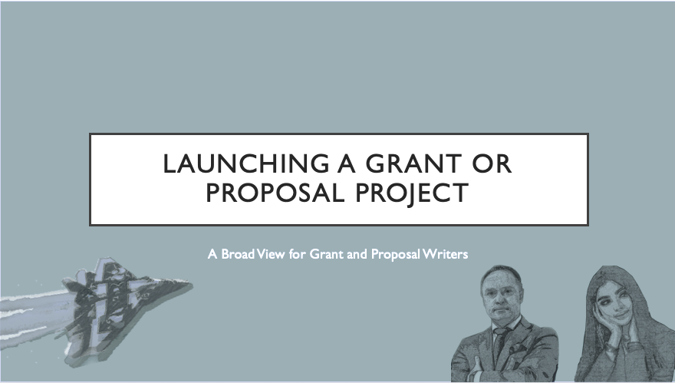
(Timed and animated presentation available by request only.)
Note: See Training_Grants and Proposals_Kickoff Meeting _Group for each resource subfolder for training groups of more than three.
© SANDSTONE EDITING 2022
Training Module: Launching a Grant or Proposal Project

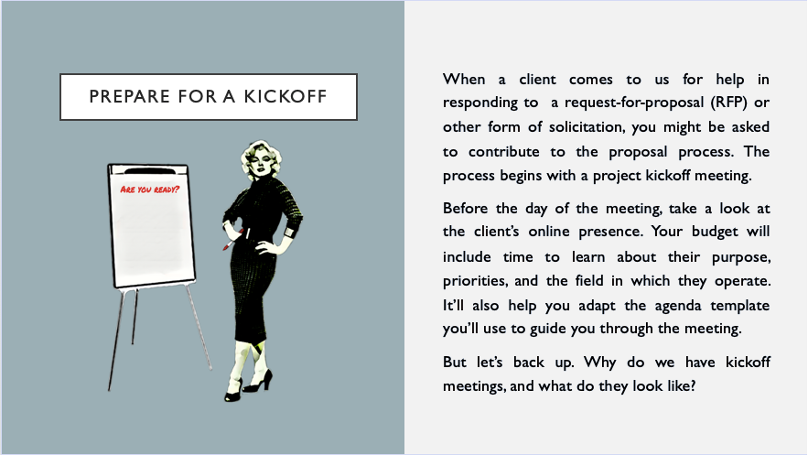
See Training_Grants and Proposals_Kickoff Meeting_Collected Anecdotes file for materials.
Pause after the slide to direct attention to Training_Grants and Proposals_Kickoff Meeting_Job_Aids_Packet, including information about icebreakers, reiterative clarifications, active listening, the difference between goals and objectives, the reasoning behind the logic model, tips for assigning responsibilities and deadlines, and tips for asking generative questions.

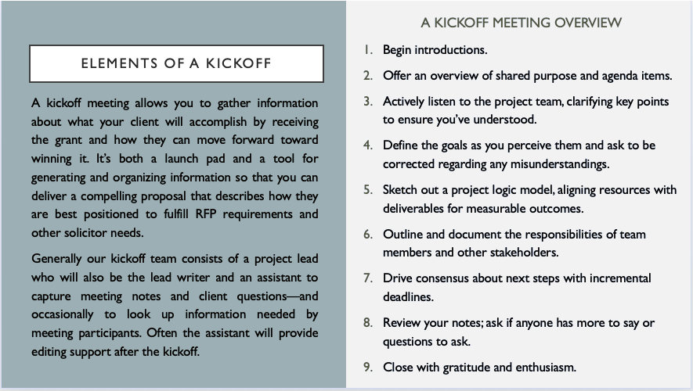
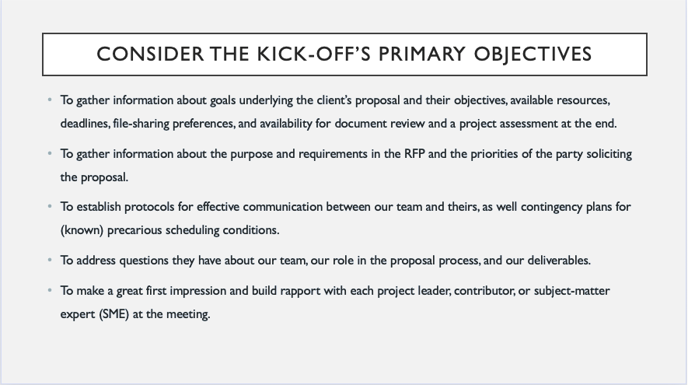
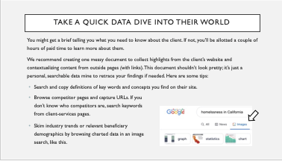
Pause for demonstration. See Training_Grants and Proposals_Kickoff Meeting_DataDive.
Before clicking to begin the list of tasks, direct learners to more handouts from the Training_Grants and Proposals_Kickoff Meeting_Job_Aids_Packet folder: Kickoff_Theory_of_Change, Kickoff_Outcome- Driven_Objectives, Kickoff_Stakeholders, and Kickoff_Common_Budget_ Concerns to review at break.

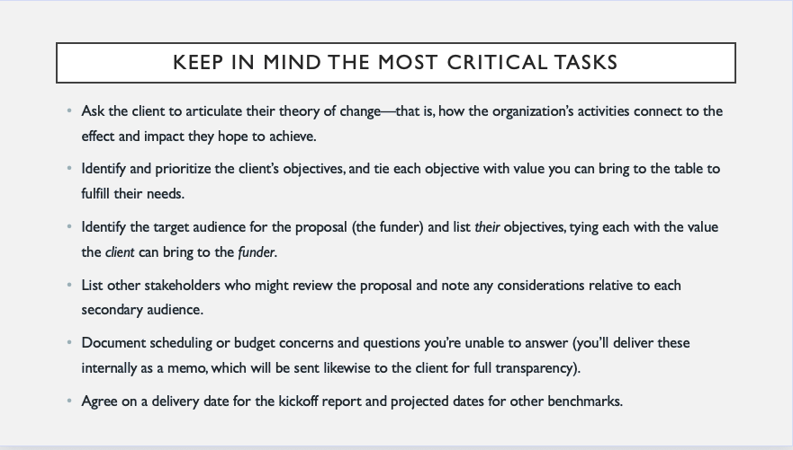
See Training_Grants and Proposals_Kickoff Meeting_Video1 _Integrated_Areas_of_Influence.

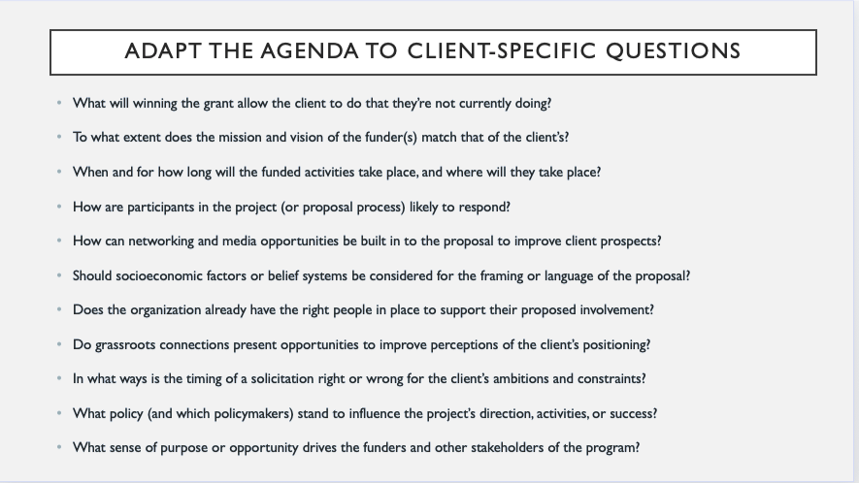
Direct attention to Training_Grants and Proposals_Kickoff Meeting_Agenda_Samples.

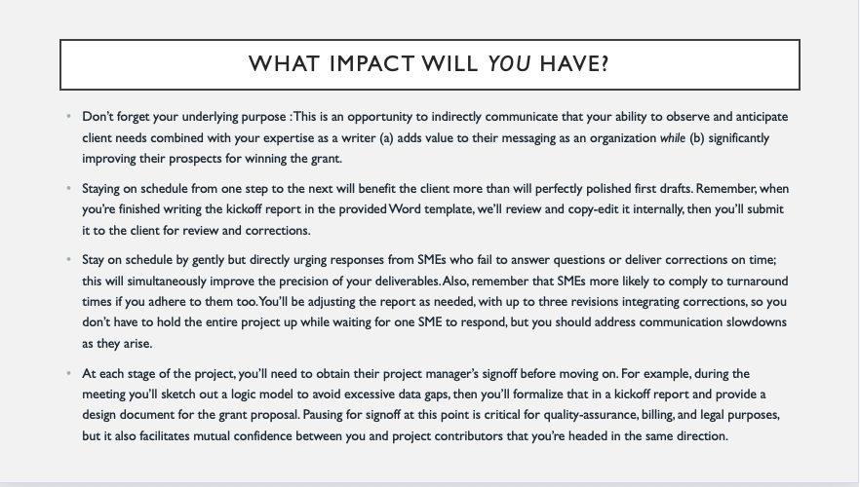
Perform mock interactions using Training_Grants and Proposals_Kickoff Meeting_Interactions_Activity if time permits.

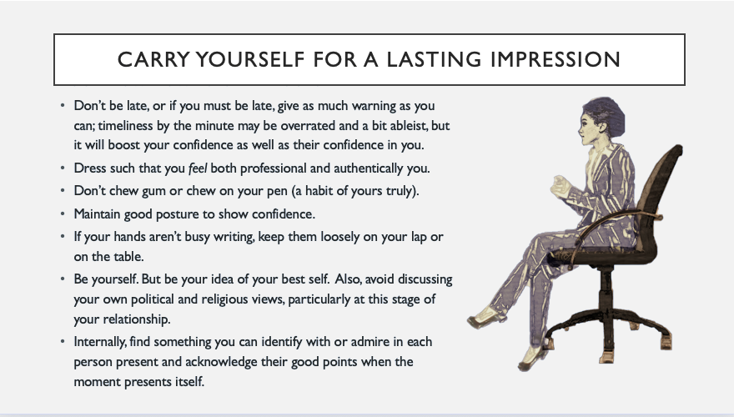
Dismiss participants for break; see Training_Grants and Proposals_Kickoff Meeting_Facilitator_Break_Checklist.

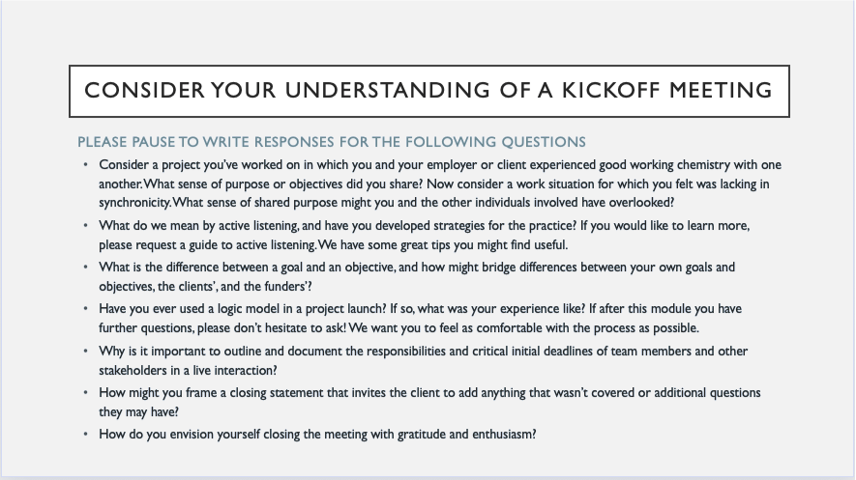
Group discussion of answers may be preferrable, depending on participants’ level of engagement and time available. Discussions can be more productive and more time-consuming.

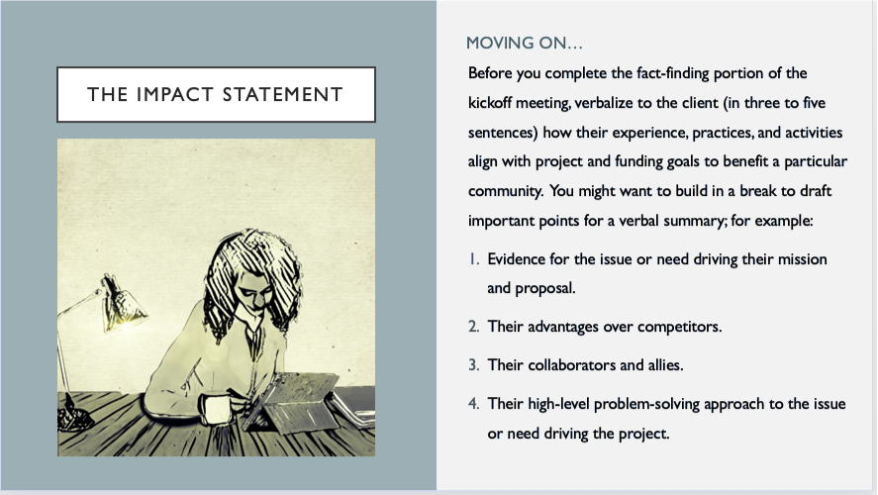
Direct attention to Training_Grants and Proposals_Kickoff Meeting_Impact Statement_Worksheet.

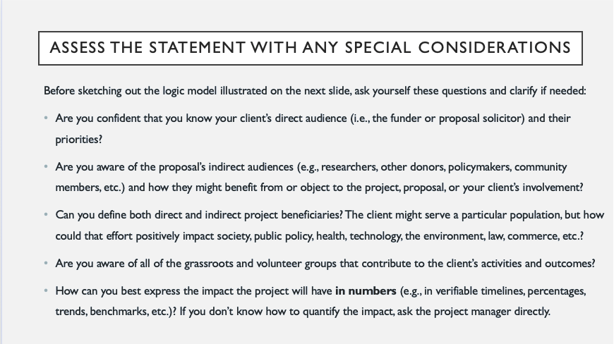
Direct attention to Training_Grants and Proposals_Kickoff Meeting_ Logic Model_Worksheet.

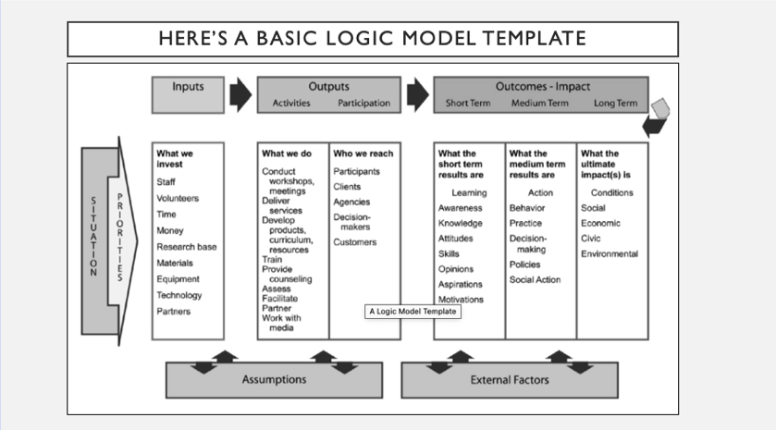
Direct attention to Training_Grants and Proposals_Kickoff Meeting_ Logic Model_Guide. Distribute participant copies of page 2 of that guide.

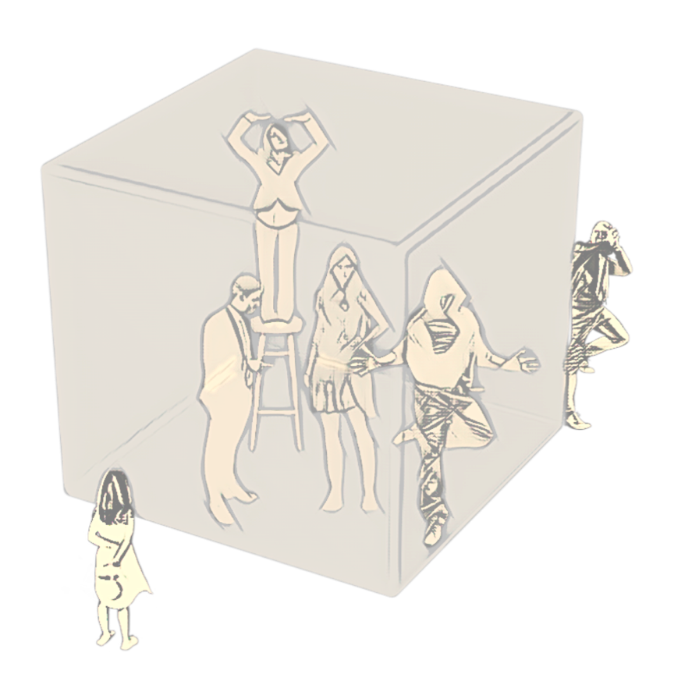
Direct attention to Training_Grants and Proposals_Kickoff Meeting_ _Internal_External_Factors.
Lead a discussion about the kinds of internal and external factors that have proved challenging for the trainee in the past. Invite questions as you go into details in the following slide sequence.
Discuss a variety of situations, asking participants to imagine an organization and to respond to questions using the Internal_External_Influences_Game file if time permits, or write the following on whiteboard:
What Does the Organization Do?
Does it conduct research or deliver services?
Does it provide training or counseling?
Does it make assessments or facilitate activities for other organizations?
Does it partner with other organizations?
Does it shape public awareness or policy?

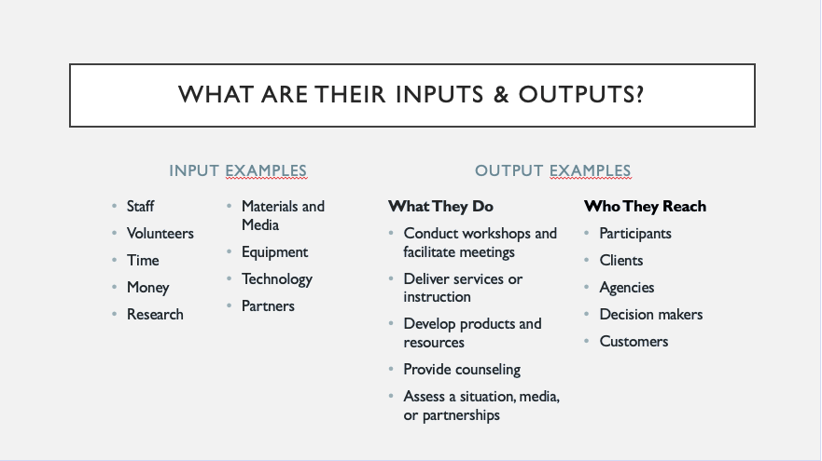
Discuss internal and external factors (inputs/outputs) that influence what they do.

See full program for remaining topics:
- Mapping Short-, Intermediate- and Long-Term Funding Outcomes
- Practices for Ensuring RFP Alignment
- Positioning the Client According to Funder Needs
- Smart Goals for Drafting an Action Plan & Impact Statement
- Clarifying & Documenting Deliverables
- The Kickoff Report Distribution & Signoff

